
Week 9, Day 3
Week 10, Day 1
Lower Body Blast #9
EXERCISE CHOICES | TIME | TARGET HR
GROUP A - Alternating Side Kicks | 60 sec. | 75-90% or 7-9 on RPE
GROUP B - Low Squat Jump Tuck | MAX REPS-60 sec | 75-90% or 7-9 on RPE
* LEVEL 3 FAT FINISHERS - Add between each exercise, then rest 45 seconds and continue.
At the end of each set, following the Fat Finishers, rest 60 seconds and begin again.
Complete sets 1,2,3 (reps x 12,10,8) of A, then B, then C, on Right Leg, then move to D,E,F on Left Leg.
This completes 1 ROUND
Repeat for ROUND 2 (sets 4,5,6) and ROUND 3 - (sets 7,8,9). Increase weight and decrease reps each set.
Then move to GROUP B
Record your weight used below (Only levels 2 and 3)
SERIOUSLY SLIMMING SETS - STRENGTH TRAINING - 1 LEG OVERLOADS
 | SET 1 | SET 2 | SET 3 | SET 4 | SET 5 | SET 6 | SET 7 | SET 8 | SET 9
A)Step Ups | 12x | 10x | 8x | 12x | 10x | 8x | 12x | 10x | 8x
B)Lunge Backs | 12x | 10x | 8x | 12x | 10x | 8x | 12x | 10x | 8x
C)1 Leg Deadlift | 12x | 10x | 8x | 12x | 10x | 8x | 12x | 10x | 8x
D) Step Ups | 12x | 10x | 8x | 12x | 10x | 8x | 12x | 10x | 8x
E)Lunge Backs | 12x | 10x | 8x | 12x | 10x | 8x | 12x | 10x | 8x
F)1 Leg Deadlift | 12x | 10x | 8x | 12x | 10x | 8x | 12x | 10x | 8x
ROUND1
ROUND2
ROUND3
ON LEFT LEG
ON RIGHT LEG
GROUP B | CIRCUITS | REPS
G) Front Squats | 2 | 12-15
H) Tip-Toe Plié Squats | 2 | 12-15
Perform A to B without break = 1 circuit | - Rest 30 sec. and complete another circuit.
COMPLETE
ALL 3 SETS
OF A ON
RIGHT LEG
FIRST,
THEN
3 SETS OF
B and C
AFTER 3 SETS OF
ABC ARE
DONE,
COMPLETE
ALL 3 SETS
OF D ON
LEFT LEG
THEN
3 SETS OF
E and F
THEN
REPEAT FROM
A FOR
TOTAL OF
3 ROUNDS

THEN GO TO
GROUP B

Seriously Sexy Legs Lower Body Blast 9
Hold a pair of dumbbells, hammer grip at shoulder height.
Feet are shoulder width apart.
Head and body upright, lower to a seated position.
Return to upright position = 1 rep.
Hold the top of the dumbbell at centre front of body.
Stand in a wider than shoulder distance stance on toes pointing outwards on a diagonal. Keeping your torso/chest upright, drop butt down and then return partway up to complete one pulse plié squat rep. Return to start position = 1 rep.

GROUP 1

A & D - OVERLOAD STEP UPS
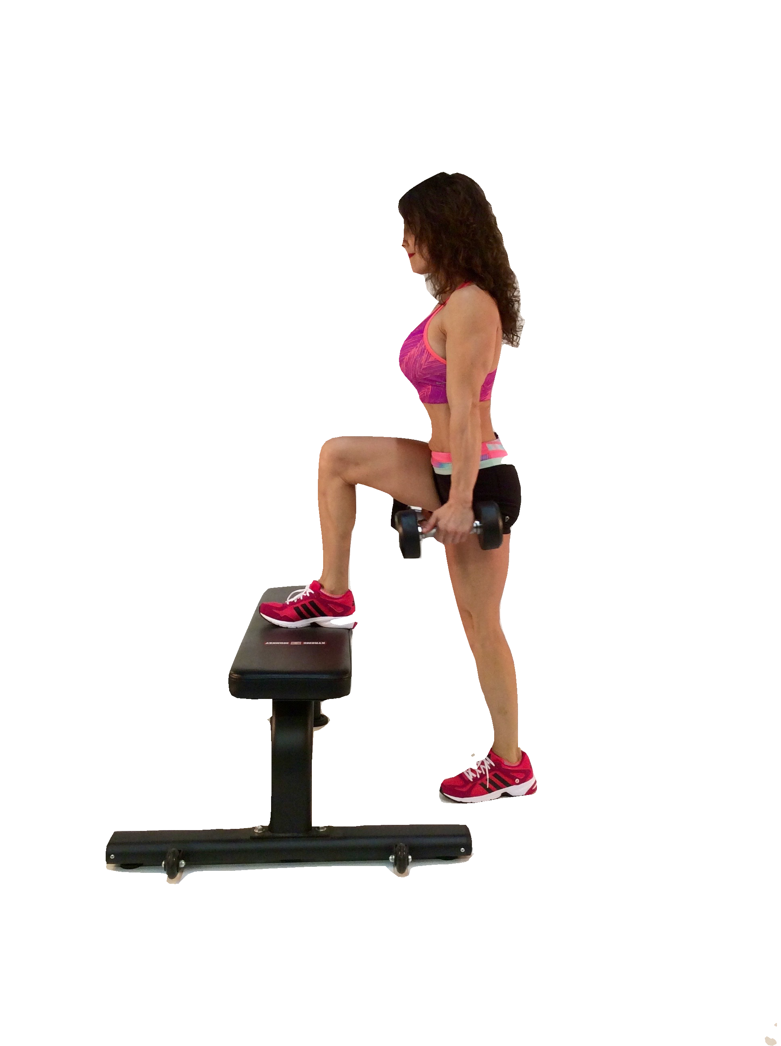

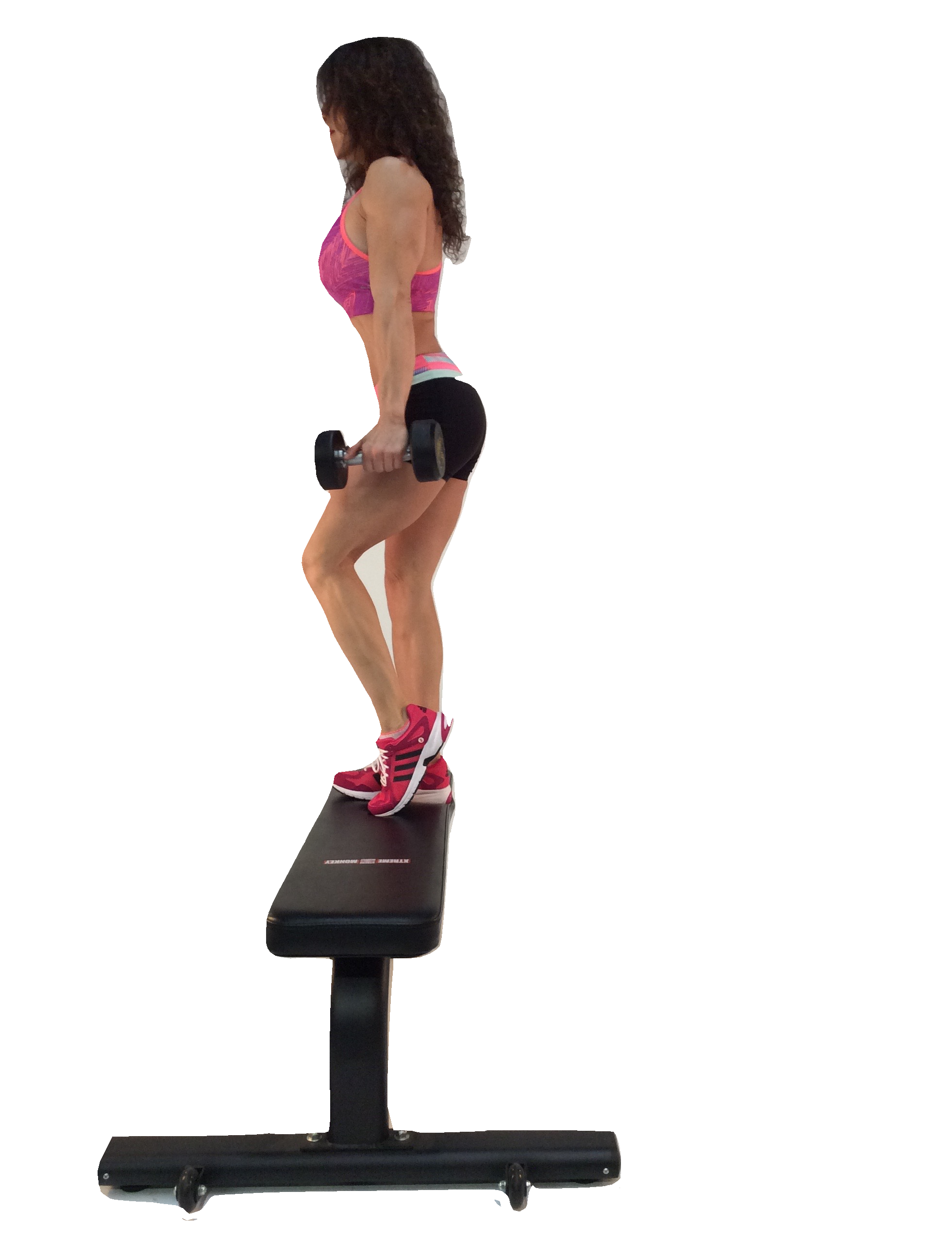
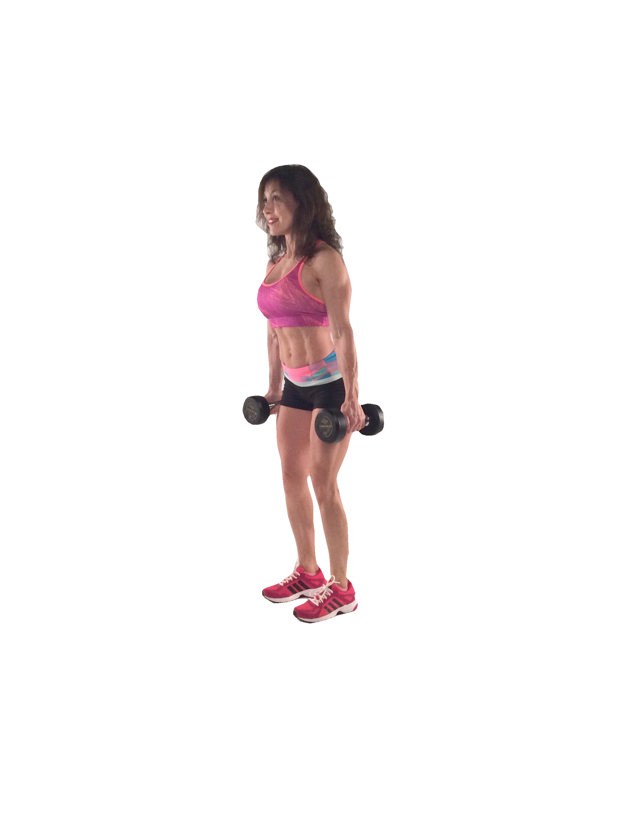
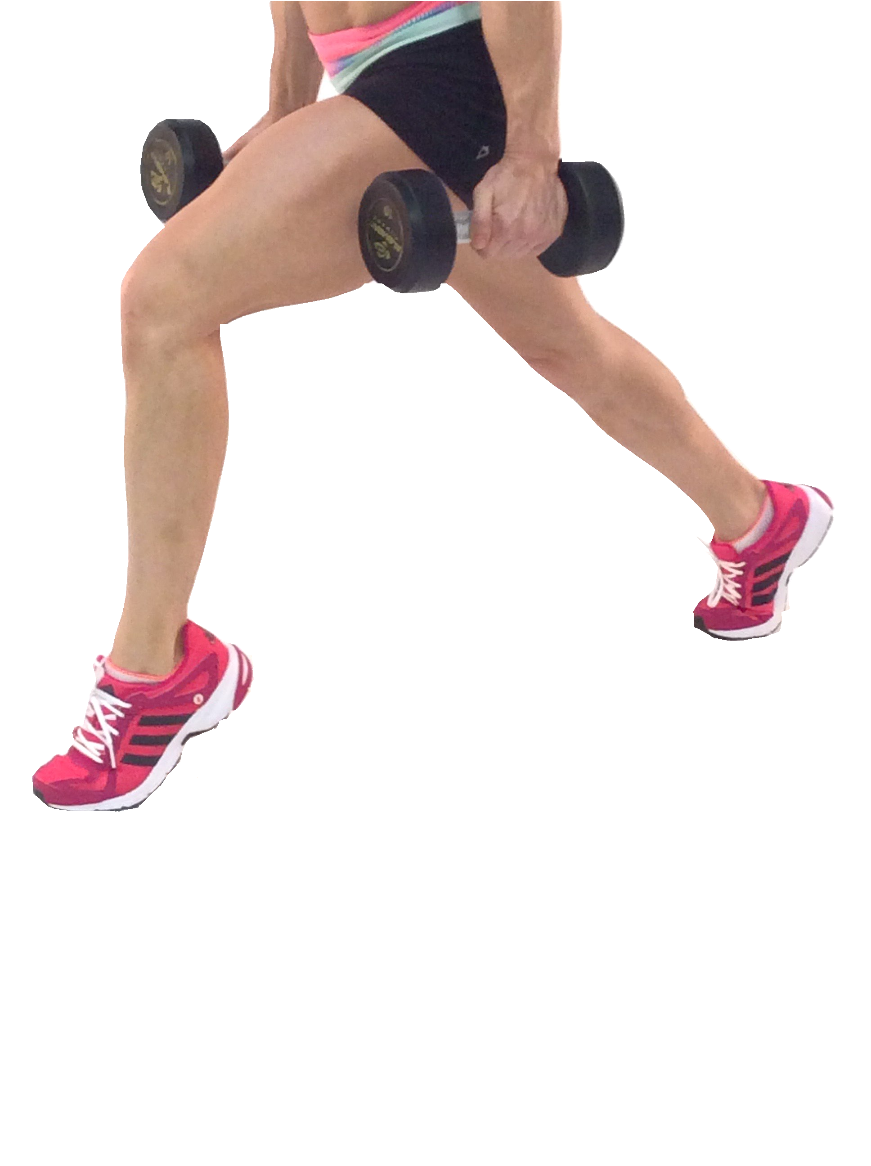
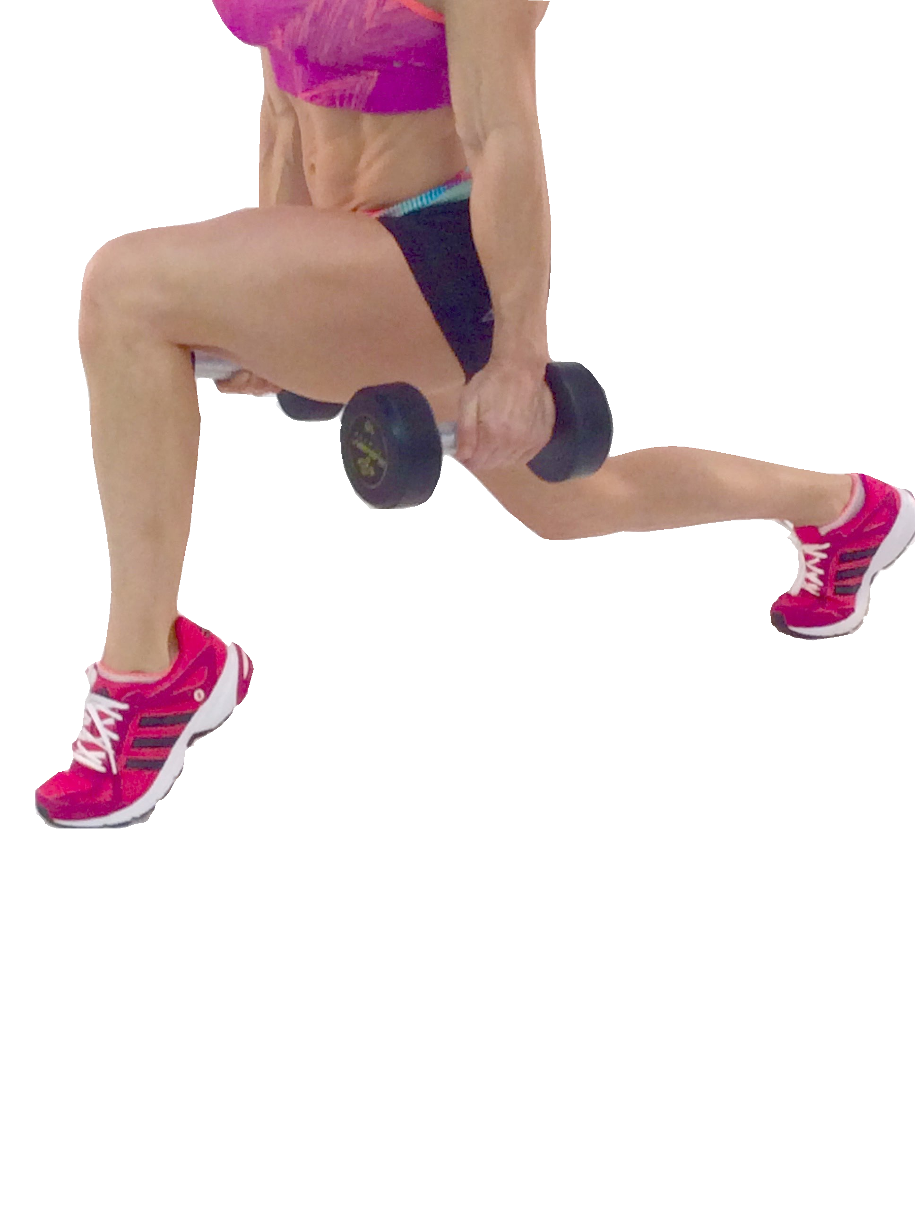
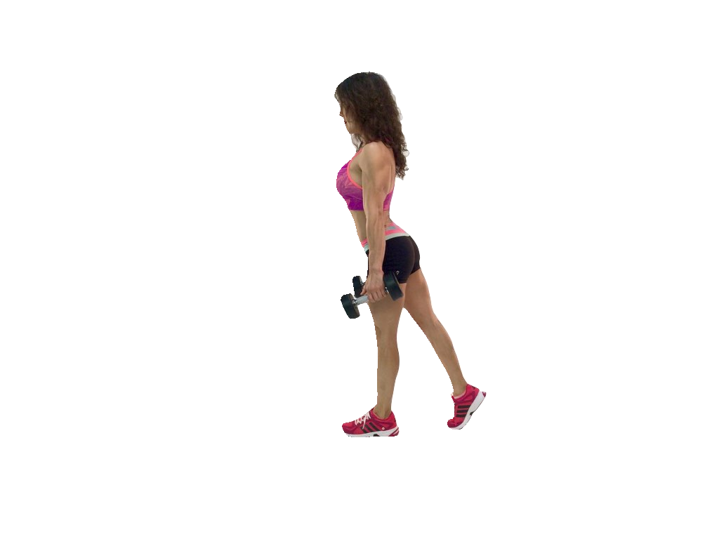
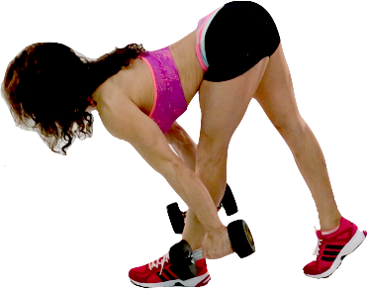
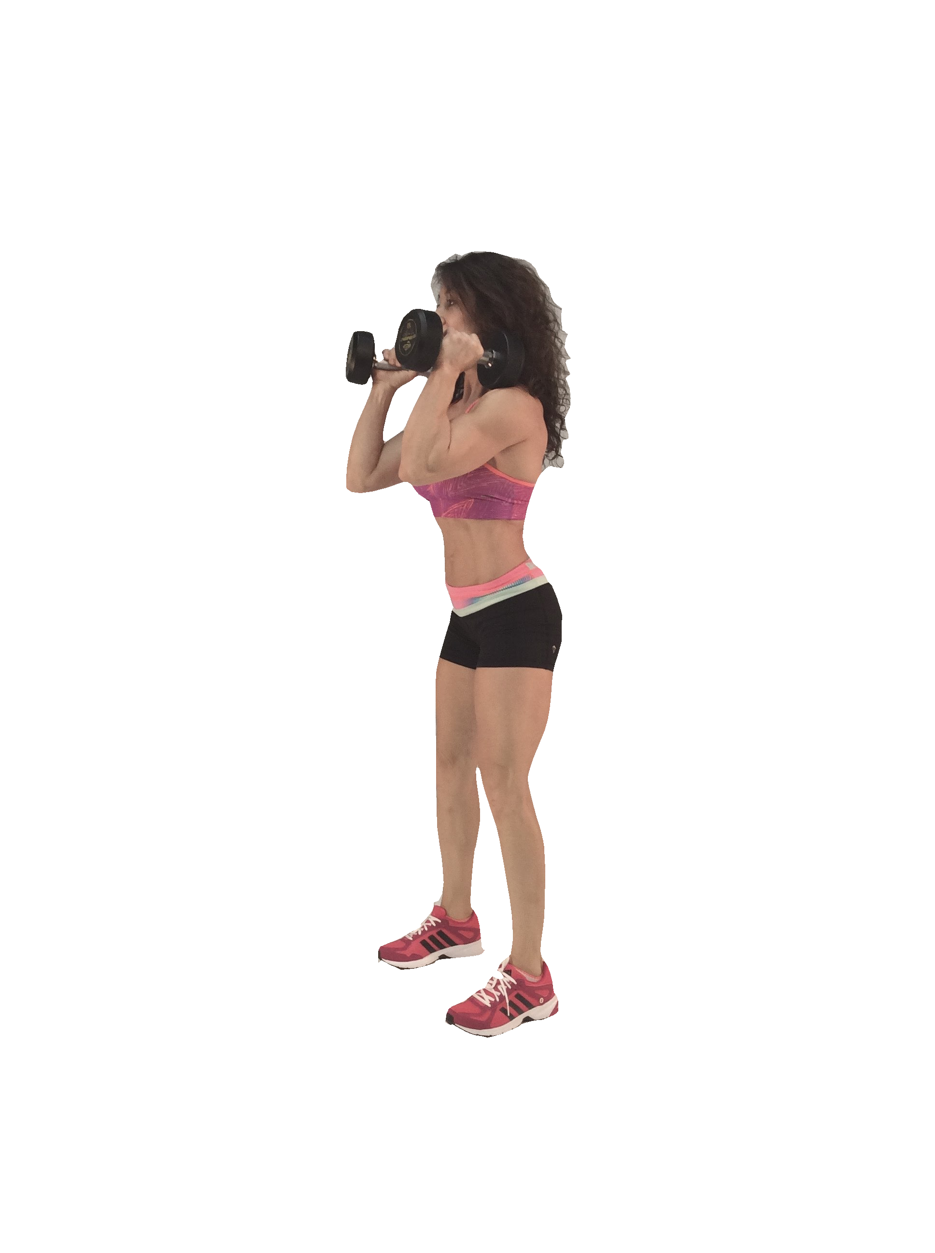
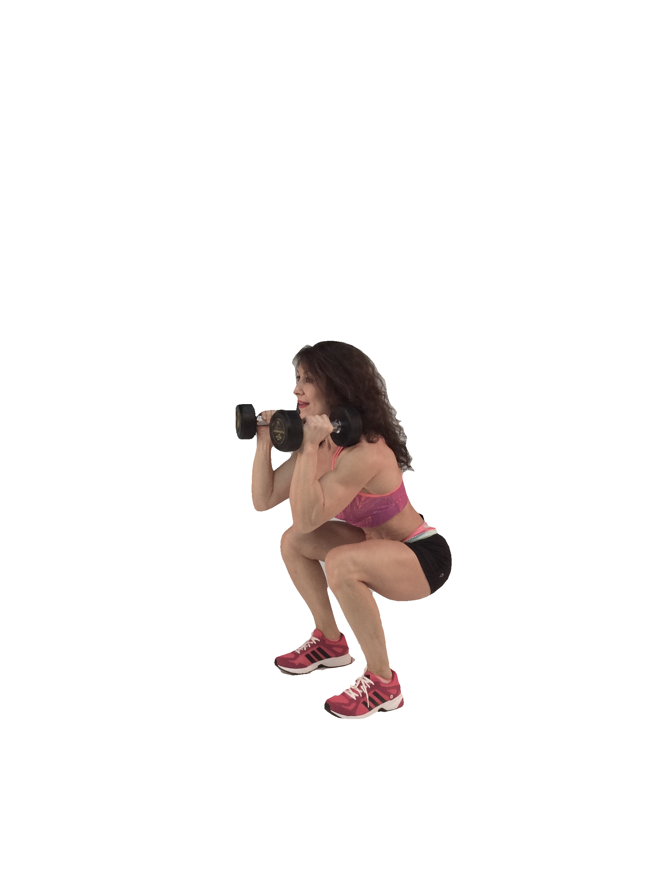
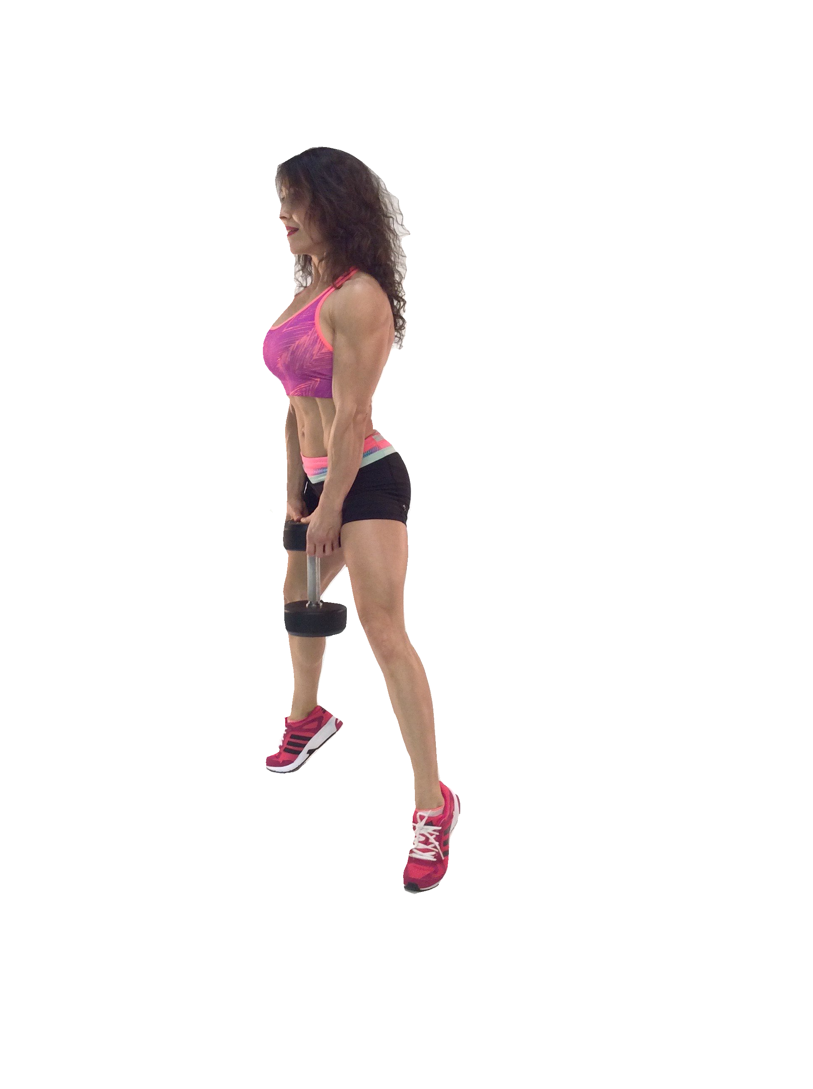
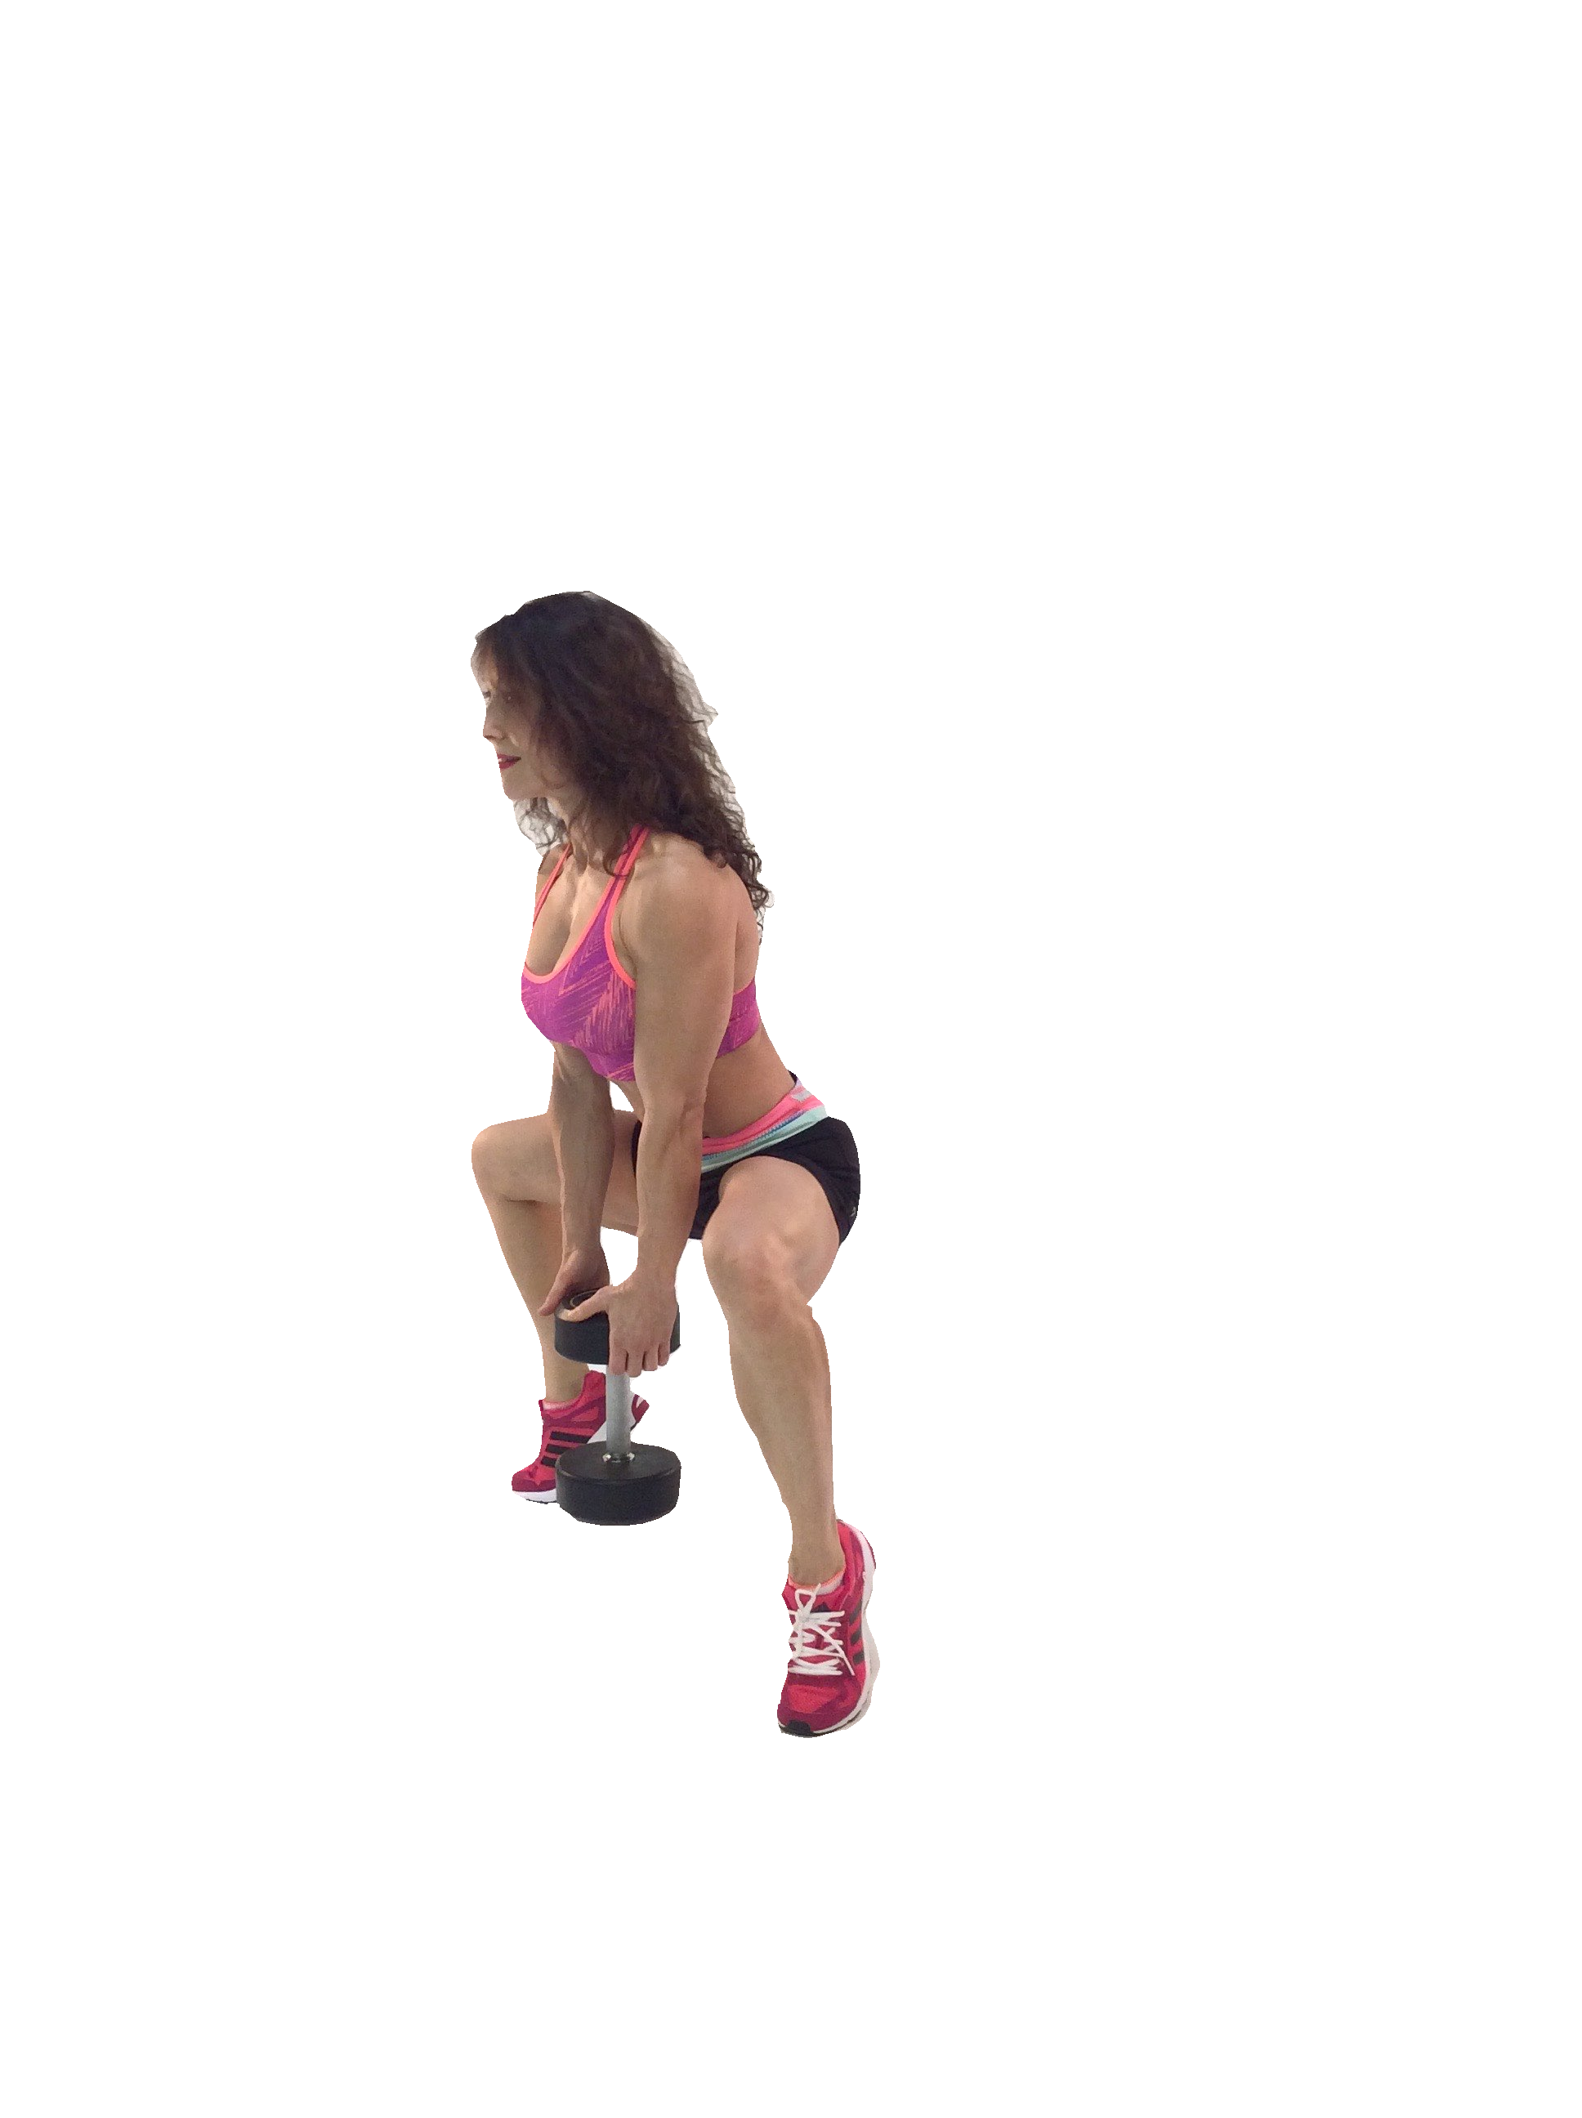
Step up and down with right leg - This equals one rep. Complete all reps on right leg.
Repeat on left leg for same amount of reps.

EXERCISES

B & E - LUNGE BACKS on TOES Holding dumbbells at side, stand with legs shoulder
width apart, knees slightly bent. 2) Step back with your right leg, landing on toes/balls of feet. *Lift heel of left leg off ground for an added challenge 3) bring back right knee as close to ﬂoor as possible and return to starting position = 1 rep.

A) B) C)

*Place foot ﬂat if
balance challenge is too great.

C & F - ONE LEGGED DEADLIFT Stand holding a pair of dumbbells at sides. Bend knees slightly. Take 1-2 steps back with right leg, on balls of feet.
Lean forward, bending at the hips slowly lowering the weights as low as you can, while maintaining a ﬂat back, until you feel a stretch in your hamstrings.
Return to upright position = 1 rep.

GROUP 2 H - TIP TOE PLIÉ SQUATS G - FRONT SQUATS

