
Lower Body Blast # 8
 | SET 1 | SET 2 | SET 3 | SET 4 | SET 5 | SET 6 | SET 7 | SET 8 | SET 9
A  Forward  Leaning Lunges | 12x | 10x | 8x | 12x | 10x | 8x | 12x | 10x | 8x
B  Curtsy Stiff Legged Deadlifts | 12x | 10x | 8x | 12x | 10x | 8x | 12x | 10x | 8x
C  Forward  Leaning Lunges | 12x | 10x | 8x | 12x | 10x | 8x | 12x | 10x | 8x
D  Curtsy Stiff Legged Deadlifts | 12x | 10x | 8x | 12x | 10x | 8x | 12x | 10x | 8x
GOALS Turbo charged sculpting, 1 legged overload. Remember to warm up and cool down.
Level 1 - Just get through the workout. No weights used, or use bands. Rest as needed.
Level 2 - Hold Dumbbells when possible. Keep rest between exercises at 30-40 seconds. Rest between sets 60-75 sec.
Level 3 - Hold dumbbells. Keep rest between exercises at strict 30 sec.
60 sec. between sets and add the*Fat Finisher intervals, now increased to 60 sec. each.
EXERCISE CHOICES | TIME | TARGET HR
Runner’s Start to One Legged Plyo  Switch lead leg every 10 reps. | 60 sec. | 75-90% or 7-9 on RPE
GROUP 2 - Deep Squat, touch floor to knee tuck jump | MAX REPS | 75-90% or 7-9 on RPE
* LEVEL 3 FAT FINISHERS - Add between each exercise, then rest 45 seconds and continue.
At the end of each set, following the Fat Finishers, rest 60 seconds and begin again.
Complete SETS 1,2,3 (reps x 12,10,8) of A, then B on Right Leg, then move to C and D on Left Leg.
This completes 1 ROUND
Repeat for ROUND 2 (sets 4,5,6) and ROUND 3 - (sets 7,8,9). Increase weight and decrease reps each set.
Then move to GROUP 2
Record your weight used below (Only levels 2 and 3)
SERIOUSLY SCULPTING SETS - STRENGTH TRAINING - 1 LEG OVERLOADS
ROUND1
ROUND2
ROUND3
ON LEFT LEG
ON RIGHT LEG
GROUP 2 | SETS | REPS | SET 1 | SET 2 | SET 3 | REST
E - 1 leg hip raise, on heels. No Weight. | 3 | 15-20
COMPLETE
ALL 3 SETS
OF A ON
RIGHT LEG
FIRST,
THEN
3 SETS OF
B
AFTER 3 SETS OF
A&B ARE
DONE,
COMPLETE
ALL 3 SETS
OF C ON
LEFT LEG
THEN
3 SETS OF
D
THEN
REPEAT FROM
A FOR
TOTAL OF
3 ROUNDS

THEN GO TO
GROUP 2

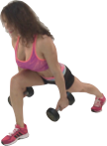
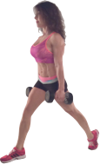
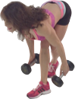
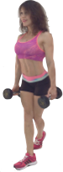
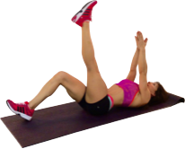
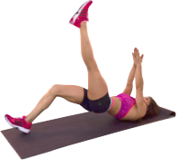
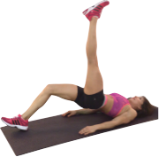
Modify if needed
Lift hips

E - HIP RAISES - SINGLE LEG on HEEL (hamstring focus)
Lying on your back with feet spaced shoulder distance apart.
Extend one leg up towards ceiling, keeping weight on the heel of stabilizing leg.
Lift hips up to highest position and squeeze glutes, lower down to start position
= 1 rep
(Modify with arms at sides on floor for added support, if needed)

A-B - FORWARD LEANING LUNGE
With one leg in front of the other, hold dumbbells at side. In a lunge position, lean forward to position your chest over your thigh, and return to start position = 1 rep
EXERCISES
GROUP 1

C-D - CURTSY STIFF LEGGED DEADLIFT
Holding dumbbells at side, stand with one foot in front and across on a diagonal. Hinge at the hips and lean forward over front leg until you feel a stretch in your hamstrings, keeping back flat. Return to upright position = 1 rep

GROUP 2
Seriously Sexy Legs
Lower Body Blast 8

